

Hospital Resource & Business Management

Faizan Razi (fhr4@njit.edu), John Makely (jm672@njit.edu)

CS331-001 Group_21

**Summary of the System Requirements**

The hospital consists of several distinct departments of which different types of employees are assigned to. Each employee is designated a schedule and assigned a number of patients and cases within that department. Each department is supported by a budget and set of hospital resources which are assigned to patients on a case by case basis. The budget determines the number of employees and amount of hospital resources available.

The employees would consist of the staff working in the hospital which would include: doctors, nurses, receptionists, technicians, pharmacists, sanitary workers, food staff, medical assistants, interns, and the management team. The database would keep a record of each employee along with their personal information such as: name, address, salary, employee ID, etc.

The employees are assigned to work on a schedule which specifies what shift each employee works. The database will keep track of the shift date, start and end times of each employee.

The database holds a record of each patient’s case. Doctors and nurses are assigned to handle a particular case determined by their specialization. The case includes information such as the patient name and ID, room number, doctor/nurse name, hospital resources needed/used, prescriptions, actions taken by personnel, and who the patient was admitted by.

Patient documentation is archived with necessary information (name, date of birth, insurance, medical history, current case, prior cases, admittance date and discharge date). Depending on their condition, a patient will be housed under a specific department.

Each department is of its own type and contains data including location, available rooms, list and number of employees, list and number of patients. They keep track of their available resources (medical equipment, patient room necessities, office supplies, pharmaceuticals, etc.). A budget is also designated, which determines the resources and staff available.

**Entity-Relationship Diagram**

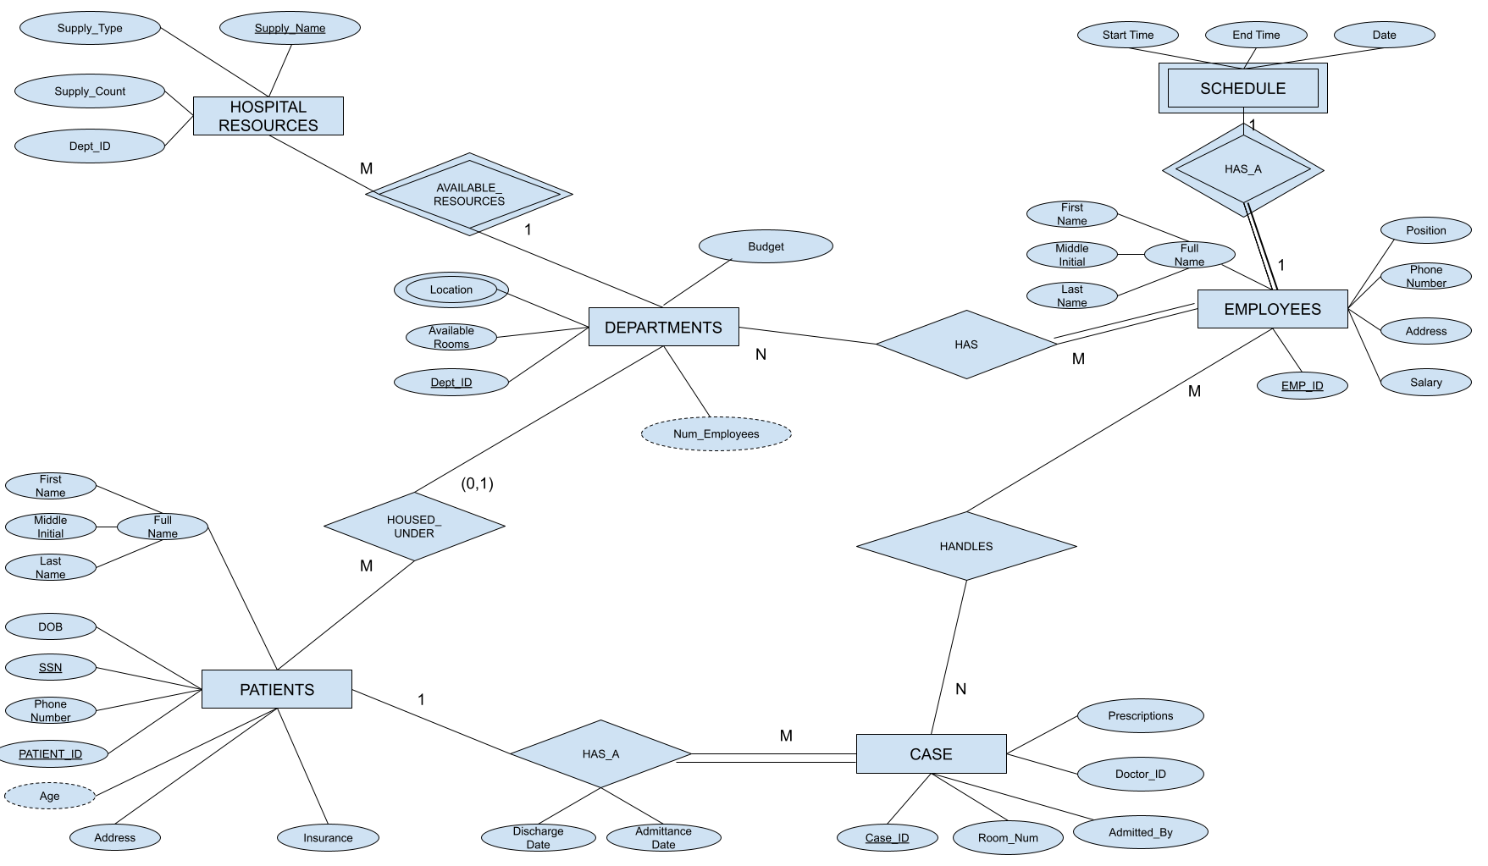

**Relational Logical Database Design**

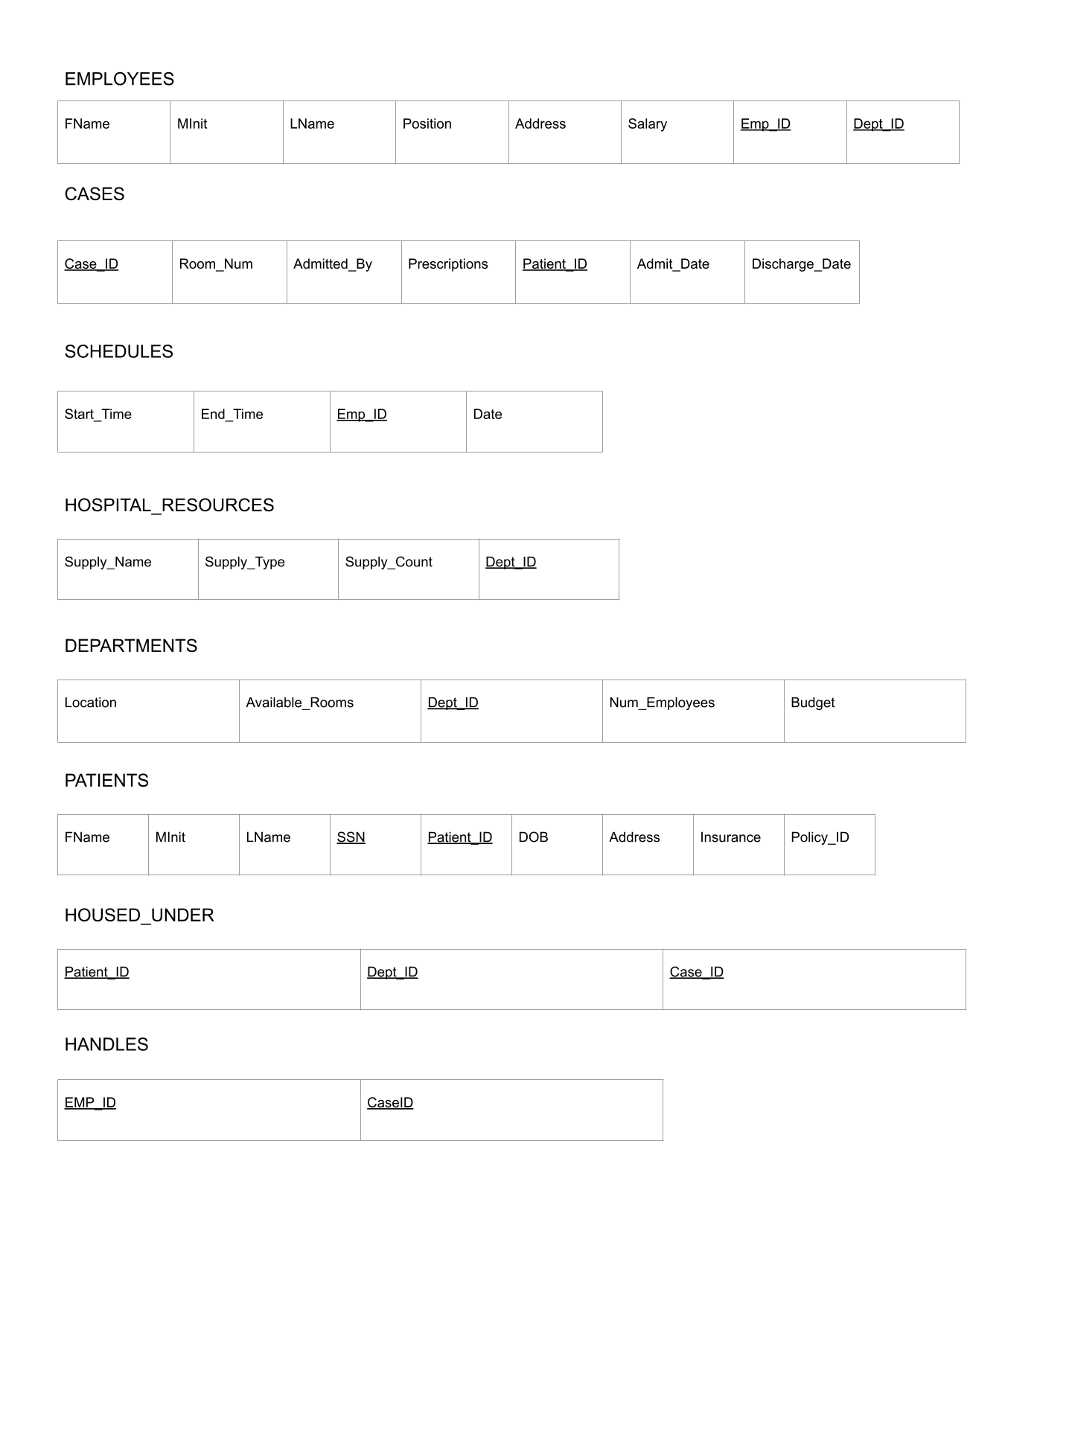

**SQL STATEMENTS AND SAMPLE DATA**

CREATE TABLE DEPARTMENTS (

Dept_ID INT NOT NULL,

Available_Rooms INT DEFAULT 0,

Location VARCHAR(15) NOT NULL,

Num_Employees INT,

Budget DECIMAL(10),

PRIMARY KEY (Dept_ID));

INSERT INTO DEPARTMENTS VALUES (120490, 5, 'Cardiology', 10, 544932.00);

INSERT INTO DEPARTMENTS VALUES (120492, 5, 'Neurology', 16, 345223.00);

INSERT INTO DEPARTMENTS VALUES (120494, 5, 'Emergency', 19, 425635.00);

INSERT INTO DEPARTMENTS VALUES (120496, 5, 'ICU', 21, 549293.00);

INSERT INTO DEPARTMENTS VALUES (120498, 5, 'Oncology', 7, 348478.00);

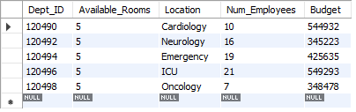

CREATE TABLE EMPLOYEES (

Fname VARCHAR(15) NOT NULL,

Minit CHAR,

LName VARCHAR(20) NOT NULL,

Position VARCHAR(20) NOT NULL,

Address VARCHAR(100),

Salary DECIMAL(6),

EMP_ID INT NOT NULL,

Dept_ID INT NOT NULL,

PRIMARY KEY (EMP_ID, Dept_ID),

FOREIGN KEY (Dept_ID) REFERENCES DEPARTMENTS (Dept_ID));

INSERT INTO EMPLOYEES VALUES ('Jack', 'C', 'Garcia', 'Doctor', '711 Nulla St Mankato Mississippi 96522', 300000, 42916008, 120498);

INSERT INTO EMPLOYEES VALUES ('Amy', 'D', 'Randy', 'Nurse', '606 Ullamcorper. Street Roseville NH 11523', 110000, 42916038, 120496);

INSERT INTO EMPLOYEES VALUES ('Susan', 'N', 'Lee', 'Doctor', '859 Sit Rd. Azusa New York 39531', 300000, 42916308, 120494);

INSERT INTO EMPLOYEES VALUES ('Jonny', 'R', 'Stan', 'Pharmacist', '7292 Dictum Av. San Antonio MI 47096', 200000, 42943508, 120492);

INSERT INTO EMPLOYEES VALUES ('Dan', 'E', 'Van', 'Receptionist', '5762 At Rd. Chelsea MI 67708', 80000, 42294608, 120490);

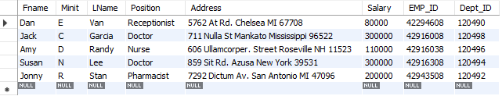

CREATE TABLE SCHEDULES(

Shift_ID INT NOT NULL,

Start_Time TIME NOT NULL,

End_Time TIME NOT NULL,

EMP_ID INT NOT NULL,

Date DATE NOT NULL,

PRIMARY KEY (EMP_ID, Shift_ID),

FOREIGN KEY(EMP_ID) REFERENCES EMPLOYEES(EMP_ID));

INSERT INTO SCHEDULES VALUES(1426, '8:00:00', '17:00:00', 42916008, '2021-11-01');

INSERT INTO SCHEDULES VALUES(2197, '9:00:00', '18:00:00', 42916038, '2021-11-03');

INSERT INTO SCHEDULES VALUES(1093, '9:00:00', '15:00:00', 42916008, '2021-11-05');

INSERT INTO SCHEDULES VALUES(4093, '6:00:00', '16:00:00', 42916008, '2021-11-07');

INSERT INTO SCHEDULES VALUES(1001, '9:30:00', '20:00:00', 42916008, '2021-11-10');

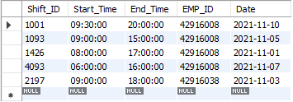

CREATE TABLE HOSPITAL_RESOURCES(

Supply_Name VARCHAR(60),

Supply_Type VARCHAR(60),

Supply_Count INT,

Dept_ID INT,

PRIMARY KEY(Supply_Name, Dept_ID),

FOREIGN KEY(Dept_ID) REFERENCES DEPARTMENTS (Dept_ID));

INSERT INTO HOSPITAL_RESOURCES VALUES("Scrubs","Patient", 200, 120490);

INSERT INTO HOSPITAL_RESOURCES VALUES("Computer","Office", 10, 120490);

INSERT INTO HOSPITAL_RESOURCES VALUES("Cardiac Monitor","Equipment", 200, 120492);

INSERT INTO HOSPITAL_RESOURCES VALUES("Defibrillator","Equipment", 20, 120490);

INSERT INTO HOSPITAL_RESOURCES VALUES("Amlodipine","Prescriptions", 10, 120490);

INSERT INTO HOSPITAL_RESOURCES VALUES("Office chair","Office Supplies", 15, 120490);

INSERT INTO HOSPITAL_RESOURCES VALUES("Print Paper","Office Supplies", 200, 120494);

INSERT INTO HOSPITAL_RESOURCES VALUES("Printer","Office Supplies", 3, 120490);

INSERT INTO HOSPITAL_RESOURCES VALUES("MRI Machine","Equipment", 1, 120490);

INSERT INTO HOSPITAL_RESOURCES VALUES("Trinocular Microscope","Equipment", 2, 120496);

INSERT INTO HOSPITAL_RESOURCES VALUES("Medical Tablet","Equipment", 11, 120490);

INSERT INTO HOSPITAL_RESOURCES VALUES("Metoprolol","Prescriptions", 200, 120498);

INSERT INTO HOSPITAL_RESOURCES VALUES("Lisinopril","Prescriptions", 200, 120490);

INSERT INTO HOSPITAL_RESOURCES VALUES("Omeprazole","Prescriptions", 200, 120492);

INSERT INTO HOSPITAL_RESOURCES VALUES("Simvastatin","Prescriptions", 200, 120490);

INSERT INTO HOSPITAL_RESOURCES VALUES("Stretcher","Patient Supplies", 2, 120496);

INSERT INTO HOSPITAL_RESOURCES VALUES("Stretcher","Patient Supplies", 2, 120494);

INSERT INTO HOSPITAL_RESOURCES VALUES("Stretcher","Patient Supplies", 2, 120492);

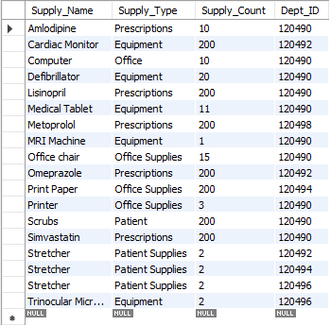

CREATE TABLE PATIENTS (

FName VARCHAR(15) NOT NULL,

MInit CHAR,

LName VARCHAR(20) NOT NULL,

SSN CHAR(9) NOT NULL,

Patient_ID INT NOT NULL,

DOB DATE,

Address VARCHAR(100),

Insurance VARCHAR(40),

Policy_ID INT,

PRIMARY KEY (SSN, Patient_ID),

UNIQUE (Patient_ID));

INSERT INTO PATIENTS VALUES ('John', 'B', 'Smith', 429166008, 45098, '1924-01-17', '2508 Dolor. Av. Muskegon KY 12482', 'United Health', 394860);

INSERT INTO PATIENTS VALUES ('Samantha', 'G', 'Williams', 429166023, 45100, '1980-11-10', '383 Suspendisse Av. Weirton IN 93479', 'Anthem Inc', 394861);

INSERT INTO PATIENTS VALUES ('Tracy', '', 'Garcia', 429166056, 45102, '1999-01-30', '4189 Nunc Road Lebanon KY 69409', 'United Health', 394862);

INSERT INTO PATIENTS VALUES ('Tommy', '', 'Pickles', 429166073, 45104, '2020-07-01', '103 Integer Rd. Corona New Mexico 08219', 'CIGNA', 394863);

INSERT INTO PATIENTS VALUES ('Susan', 'A', 'Lee', 429166092, 45106, '2004-05-27', '8679 Sodales Av. Tamuning PA 10855', 'Blue Cross Blue Shield', 394864);

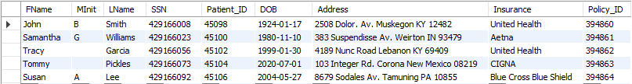

CREATE TABLE CASES(

Case_ID INT NOT NULL,

Room_Num INT,

Admitted_By INT NOT NULL,

Prescriptions VARCHAR(30),

Patient_ID INT NOT NULL,

Admit_Date DATE NOT NULL,

Discharge_Date DATE,

PRIMARY KEY (Case_ID, Patient_ID),

FOREIGN KEY(Patient_ID) REFERENCES PATIENTS(Patient_ID));

INSERT INTO CASES VALUES(38429, 21, 42916008, 'Atorvastatin', 45098, '2021-11-01', '2021-11-02');

INSERT INTO CASES VALUES(38430, 22, 42916308, 'Omeprazole', 45100, '2021-11-02', '2021-11-07');

INSERT INTO CASES VALUES(38431, 23, 42916008, 'Albuterol', 45102, '2021-11-04', '2021-11-10');

INSERT INTO CASES VALUES(38432, 24, 42916308, 'Amlodipine', 45104, '2021-11-06', '2021-11-10');

INSERT INTO CASES VALUES(38433, 25, 42916308, 'Metformin', 45106, '2021-11-11', '2021-11-23');

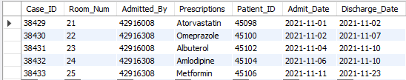

CREATE TABLE HANDLES (

Emp_ID INT NOT NULL,

Case_ID INT NOT NULL,

PRIMARY KEY (EMP_ID, Case_ID),

FOREIGN KEY (EMP_ID) REFERENCES EMPLOYEES (EMP_ID),

FOREIGN KEY (Case_ID) REFERENCES CASES (Case_ID)

);

INSERT INTO HANDLES (SELECT 42916008, 38429);

INSERT INTO HANDLES (SELECT 42916038, 38430);

INSERT INTO HANDLES (SELECT 42916308, 38431);

INSERT INTO HANDLES (SELECT 42943508, 38432);

INSERT INTO HANDLES (SELECT 42294608, 38433);

INSERT INTO HANDLES (SELECT 42916308, 38430);

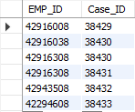

CREATE TABLE HOUSED_UNDER (

Patient_ID INT NOT NULL,

Dept_ID INT NOT NULL,

Case_ID INT NOT NULL,

PRIMARY KEY (Patient_ID, Dept_ID, Case_ID),

FOREIGN KEY (Patient_ID) REFERENCES PATIENTS (Patient_ID),

FOREIGN KEY (Case_ID) REFERENCES CASES (Case_ID),

FOREIGN KEY (Dept_ID) REFERENCES DEPARTMENTS (Dept_ID)

);

INSERT INTO HOUSED_UNDER VALUES (45098, 120490, 38429);

INSERT INTO HOUSED_UNDER VALUES (45100, 120492, 38429);

INSERT INTO HOUSED_UNDER VALUES (45102, 120494, 38429);

INSERT INTO HOUSED_UNDER VALUES (45104, 120496, 38429);

INSERT INTO HOUSED_UNDER VALUES (45106, 120498, 38429);

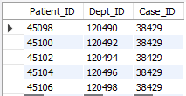

**GROUP BY Query**

SELECT Fname, Lname, AVG(Salary)

FROM EMPLOYEES

GROUP BY Position;

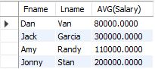

**Nested Query with ALL**

SELECT Fname, Lname

FROM EMPLOYEES

WHERE Salary > ALL (SELECT Salary

FROM EMPLOYEES

WHERE EMP_ID=42916038);

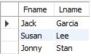

**GROUP BY and HAVING Query**

SELECT Emp_ID, COUNT(*)

FROM CASES AS C, HANDLES AS H

WHERE C.Case_ID = H.Case_ID

GROUP BY Emp_ID

HAVING COUNT(*) > 1;



**Nested Query with IN**

SELECT Dept_ID, Available_Rooms, Location

FROM DEPARTMENTS

WHERE Dept_ID IN ( SELECT Dept_ID

FROM HOSPITAL_RESOURCES

WHERE Available_Rooms > Supply_Count AND Supply_Name = "Stretcher");

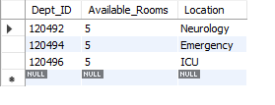

**Update Query**

UPDATE PATIENTS

SET Insurance = 'medicare'

WHERE Patient_ID = 45100;

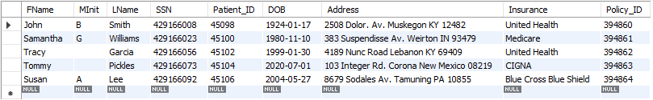

**Delete Query**

DELETE FROM HANDLES

WHERE Emp_ID = 42916308;

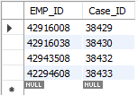

**CREATE VIEW Query**

CREATE VIEW E_BENEFITS

AS SELECT Fname, Minit, LName, Address, Salary

FROM EMPLOYEES

WHERE Salary > 40000;

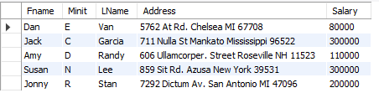

**CONCLUSION**

Our group had an overall positive experience creating the “Hospital Resource and Business Management” database. The most challenging part was creating sample data for the junction table HANDLES. The table relies solely on foreign keys, but displayed a syntax error when we tried to insert values. In order to insert new data into this table, we learned that we must use the SELECT statement to target already existing data.

Another challenge we ran into were with the columns of the HOSPITAL_RESOURCES table. In our initial design, columns for equipment, office supplies and prescriptions were all contained in separate values of data type VARCHAR. We agreed that storing the data in this manner did not make very much sense, and so we opted to rework the columns of HOSPITAL_RESOURCES. After the changes, the role the table plays in the database is now much clearer. Also, the database is able to store values of the table much more efficiently.

The easiest part of the project was troubleshooting because SQL’s error codes were extremely specific. Additionally, writing sample data for the tables gave us no troubles, since we understood that our foreign keys must line up with each other. If we were to create the database again, we would have created more departments (Sanitary, Financial, etc.) which would in turn bring forward new relations.